**COMP9336 – Mobile Data Networking**

**Lab 6 - Frequency Planning and RSS Measurement of Cellular Networks**

**T2 2022**

**Name:** Yuhua Zhao – **ZID:** z5404443

**Date**: 13/07/2022

## Task 1 Frequency Re-use

1. **Frequency Re-use factor of 1/9**

For a frequency re-use factor of 1/9 (cluster size = 9), show the nearest cochannel cells for cell-A shown in the map of Figure 1

1. **Frequency Re-use factor of 1/12**

For a frequency re-use factor of 1/12 (cluster size = 12), show the nearest cochannel

cells for cell-A shown in the map of Figure 1.

**

1. **Frequency Re-use factor of 1/9**

Using the map of Figure 1, show clusters of size 9 repeated all over the map. Use the letters A to I to represent the 9 members of each cluster. For ease of visualisation, outline the cluster borders with a different colour.

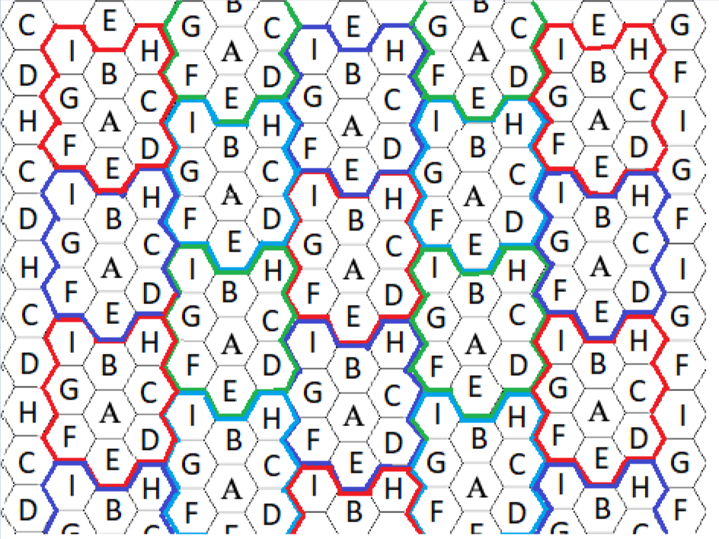



## Task 2 Measuring cellular signal strength [2 marks]

**Note:** My phone can only have the “rsrp” Information without the RSSI.

According to the diagram above, all the numbers shown above are the LTE “rsrp” value. According to the diagram above with the rsrp value. It shows that when the phone is on the chair, the rsrp is better than on the floor. Potentially it is because of the Signal Tower is quite far away from my location, the overall rsrp is relatively low. But due to the rsrp value, the Signal tower is closer to the bottom part of the house.

Within the Square are indoor areas, from my experiment the indoor signal and the outdoor are similar potentially because the lower frequency band has very good signal penetration.

**Note and prove:**

The is the Screenshot that I took at the end of the experiment.

Due to my Carrier (Belong) only support 4G, so we are focusing on the LTE rsrp.

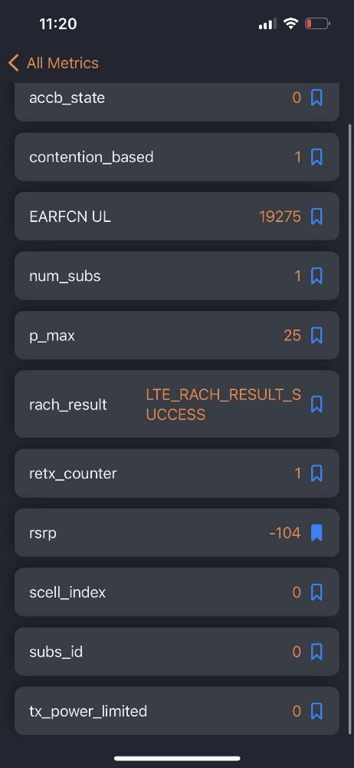

As shown on the left hand side, the